NAME : MUBARA ASHFAQ

DEPARTMENT : SE

ASSIGNMENT NO 3

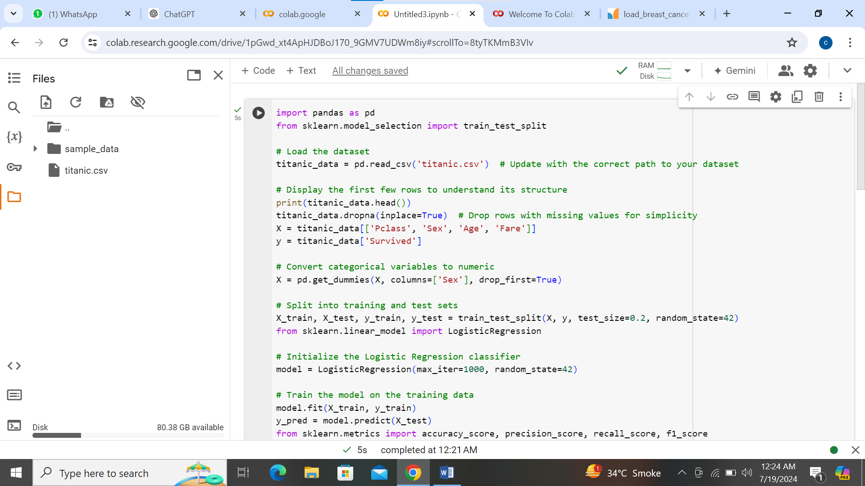

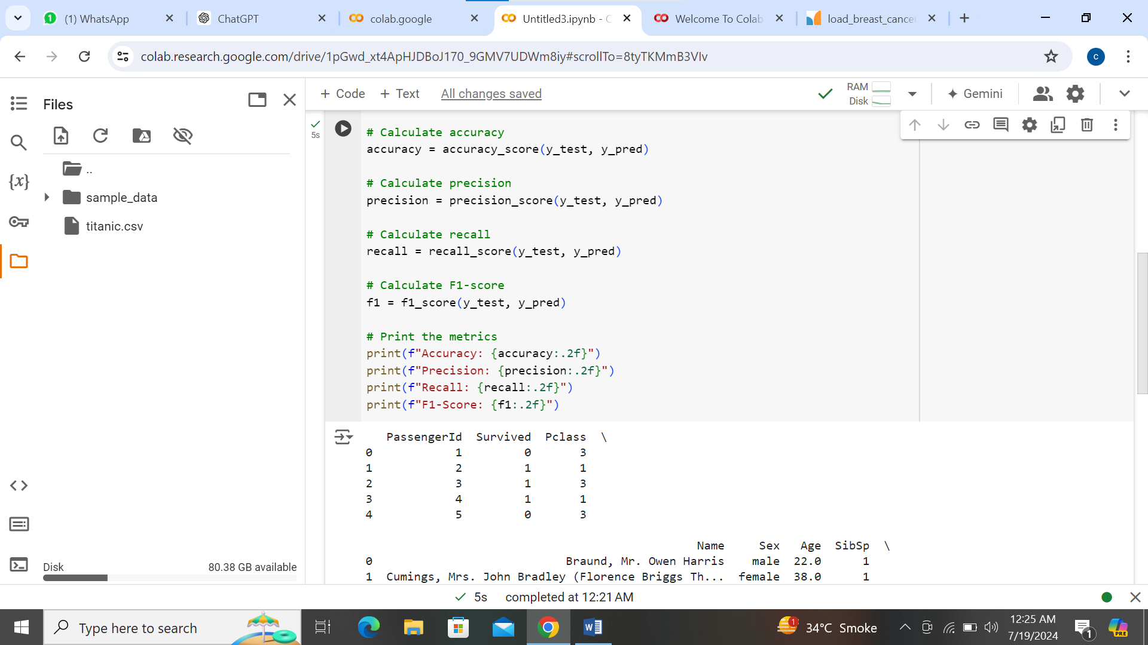

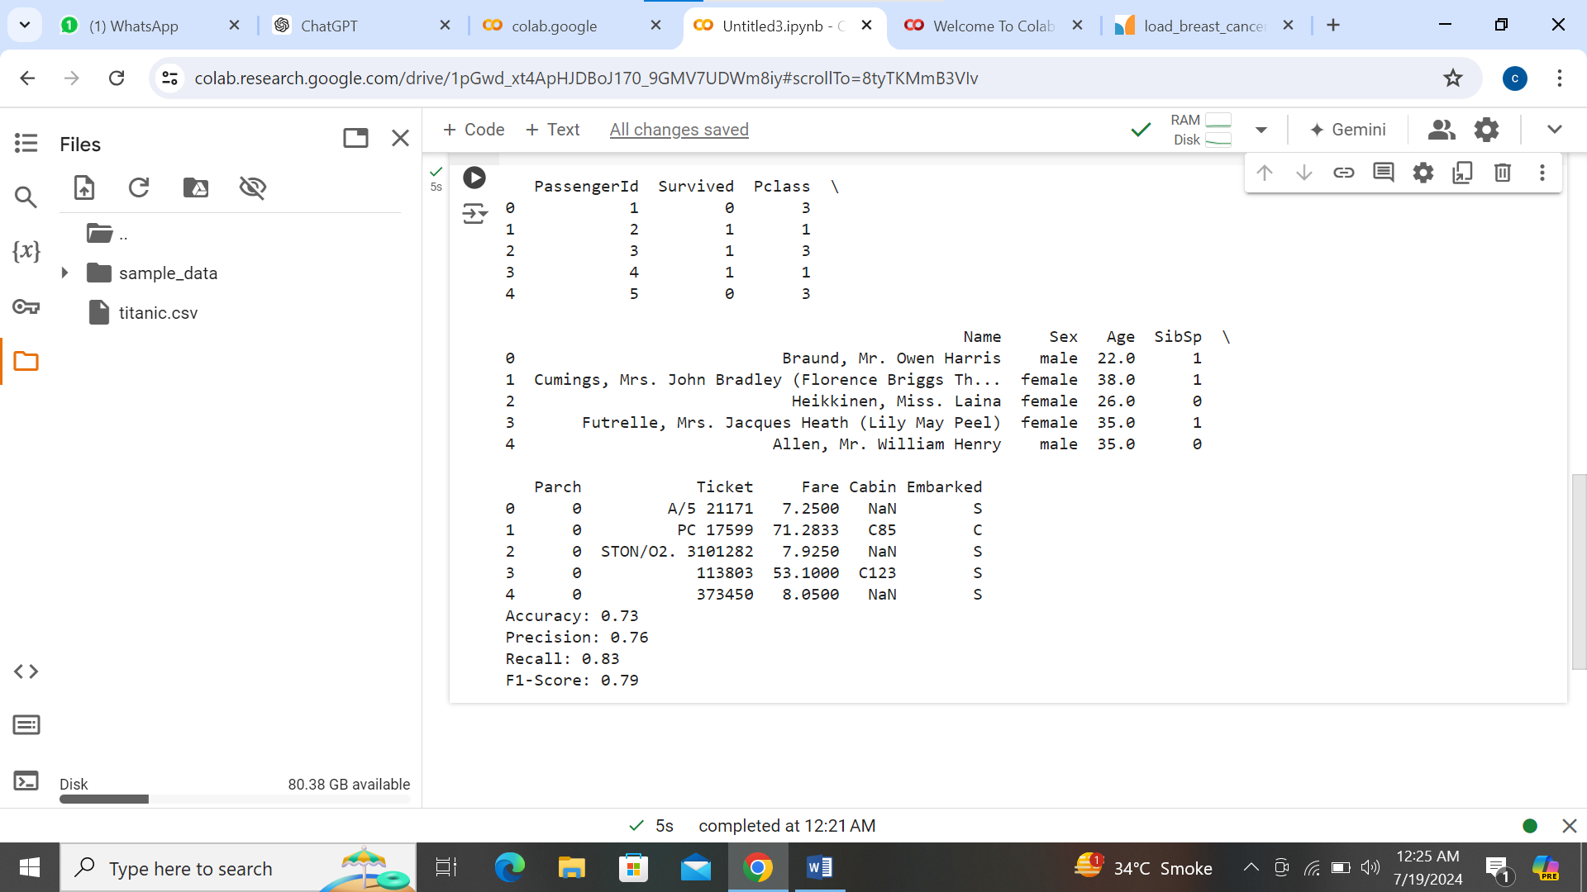

**Metrics and Interpretation:**

1. **Accuracy**:
   * Accuracy measures the proportion of correctly predicted instances (both true positives and true negatives) out of the total number of instances.
   * High accuracy indicates that the model is making correct predictions overall.
2. **Precision**:
   * Precision measures the proportion of true positive predictions (correctly predicted positives) out of all positive predictions made by the model.
   * High precision indicates that when the model predicts a positive result, it is likely to be correct.
3. **Recall** (or Sensitivity):
   * Recall measures the proportion of true positive predictions out of all actual positive instances in the dataset.
   * High recall indicates that the model is able to identify a large proportion of positive instances correctly.
4. **F1-Score**:
   * F1-score is the harmonic mean of precision and recall, providing a single metric that balances both measures.
   * It is particularly useful when you want to seek a balance between precision and recall.

**Interpretation Example:**

Let's say you trained a logistic regression model on the Titanic dataset and obtained the following metrics:

* Accuracy: 0.80
* Precision: 0.75
* Recall: 0.70
* F1-Score: 0.72

These metrics tell you the following about your model's performance:

* **Accuracy of 0.80**: The model correctly predicts survival or death for 80% of the passengers in the test set.
* **Precision of 0.75**: When the model predicts a passenger survived (positive prediction), it is correct 75% of the time.
* **Recall of 0.70**: The model correctly identifies 70% of all actual survivors in the dataset.
* **F1-Score of 0.72**: This harmonic mean indicates a balanced performance between precision and recall.

**Conclusion:**

These metrics collectively provide a comprehensive evaluation of your model's ability to predict survival on the Titanic dataset. They help in understanding not only how accurate the model's predictions are but also its ability to correctly identify survivors (recall) and its precision in predicting survival when it makes positive predictions.

In practice, you would interpret these metrics based on the specific problem context and the trade-offs between precision and recall that are acceptable for your application. For instance, in some cases, you might prioritize high precision to minimize false positives, while in others, high recall might be more important to capture all positive instances, even if it means more false positives.

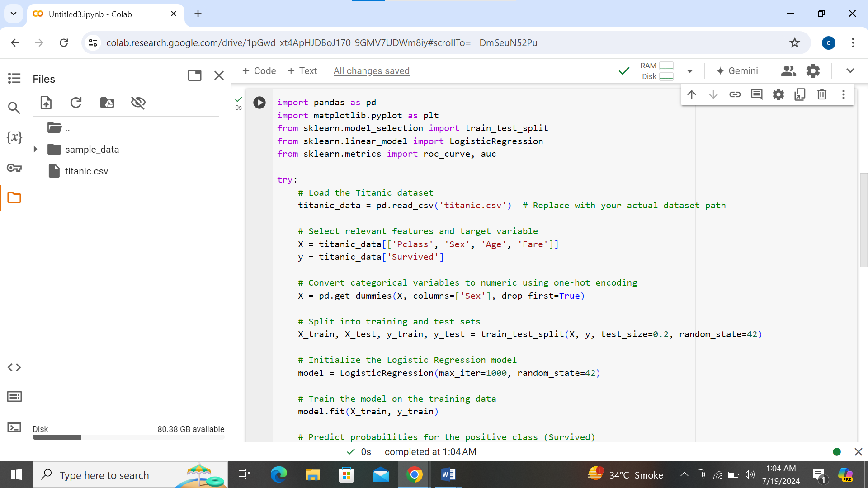

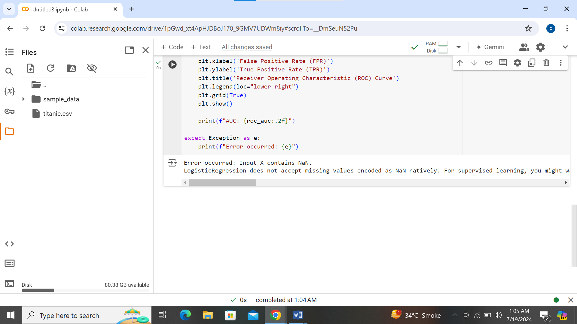

mportant metrics used to evaluate the performance of binary classification models like logistic regression. Let's delve into what these metrics indicate and how they help in assessing your model's performance on the Titanic dataset.

**ROC Curve Interpretation:**

The ROC curve plots the True Positive Rate (TPR) against the False Positive Rate (FPR) at various threshold settings. Here’s what the components of the ROC curve signify:

* **True Positive Rate (TPR)**: Also known as sensitivity or recall, TPR measures the proportion of actual positive cases (survived passengers) that are correctly identified as positive by the model. It is calculated as:

TPR=TPTP+FN\text{TPR} = \frac{\text{TP}}{\text{TP} + \text{FN}}TPR=TP+FNTP​

where TP is True Positives and FN is False Negatives.

* **False Positive Rate (FPR)**: Measures the proportion of actual negative cases (non-survived passengers) that are incorrectly classified as positive. It is calculated as:

FPR=FPFP+TN\text{FPR} = \frac{\text{FP}}{\text{FP} + \text{TN}}FPR=FP+TNFP​

where FP is False Positives and TN is True Negatives.

* **ROC Curve Shape**: The ROC curve typically rises steeply from the bottom-left corner (0,0) towards the top-left corner (0,1) and then flattens towards the top-right corner (1,1). The closer the curve follows the left-hand border and then the top border of the ROC space, the more accurate the model.

**AUC (Area Under the Curve):**

The AUC quantifies the overall performance of the binary classification model across all possible classification thresholds. It represents the probability that the model ranks a randomly chosen positive instance higher than a randomly chosen negative instance. AUC ranges from 0 to 1, where:

* A model with an AUC of 1 perfectly separates the positive and negative classes.
* A model with an AUC of 0.5 performs as well as random guessing.

**Evaluation of Model Performance:**

* **Interpretation**: A higher AUC indicates better discrimination ability of the model. In the context of the Titanic dataset, a higher AUC suggests that the model can distinguish between passengers who survived and those who did not with greater accuracy.
* **Comparison**: ROC curves and AUC provide a comprehensive way to compare different models. If you have multiple models trained on the same dataset, comparing their ROC curves and AUC values can help in selecting the best-performing model.
* **Threshold Selection**: ROC curves help in selecting the optimal threshold for making classifications based on specific needs (e.g., maximizing sensitivity or specificity).
* **Robustness**: AUC is particularly useful when dealing with imbalanced datasets, where the number of instances of one class is much higher than the other. It provides a single metric that summarizes the model’s performance across different threshold settings.

**Conclusion:**

In summary, the ROC curve visually assesses the trade-off between true positive rate and false positive rate, while the AUC quantifies the model's ability to distinguish between classes. These metrics are crucial in evaluating and comparing the performance of your logistic regression model on the Titanic dataset, providing insights into its predictive accuracy and robustness.

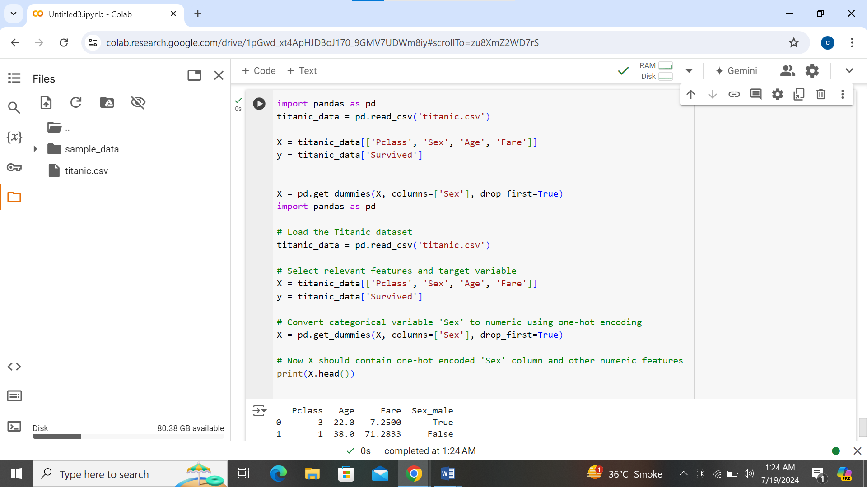

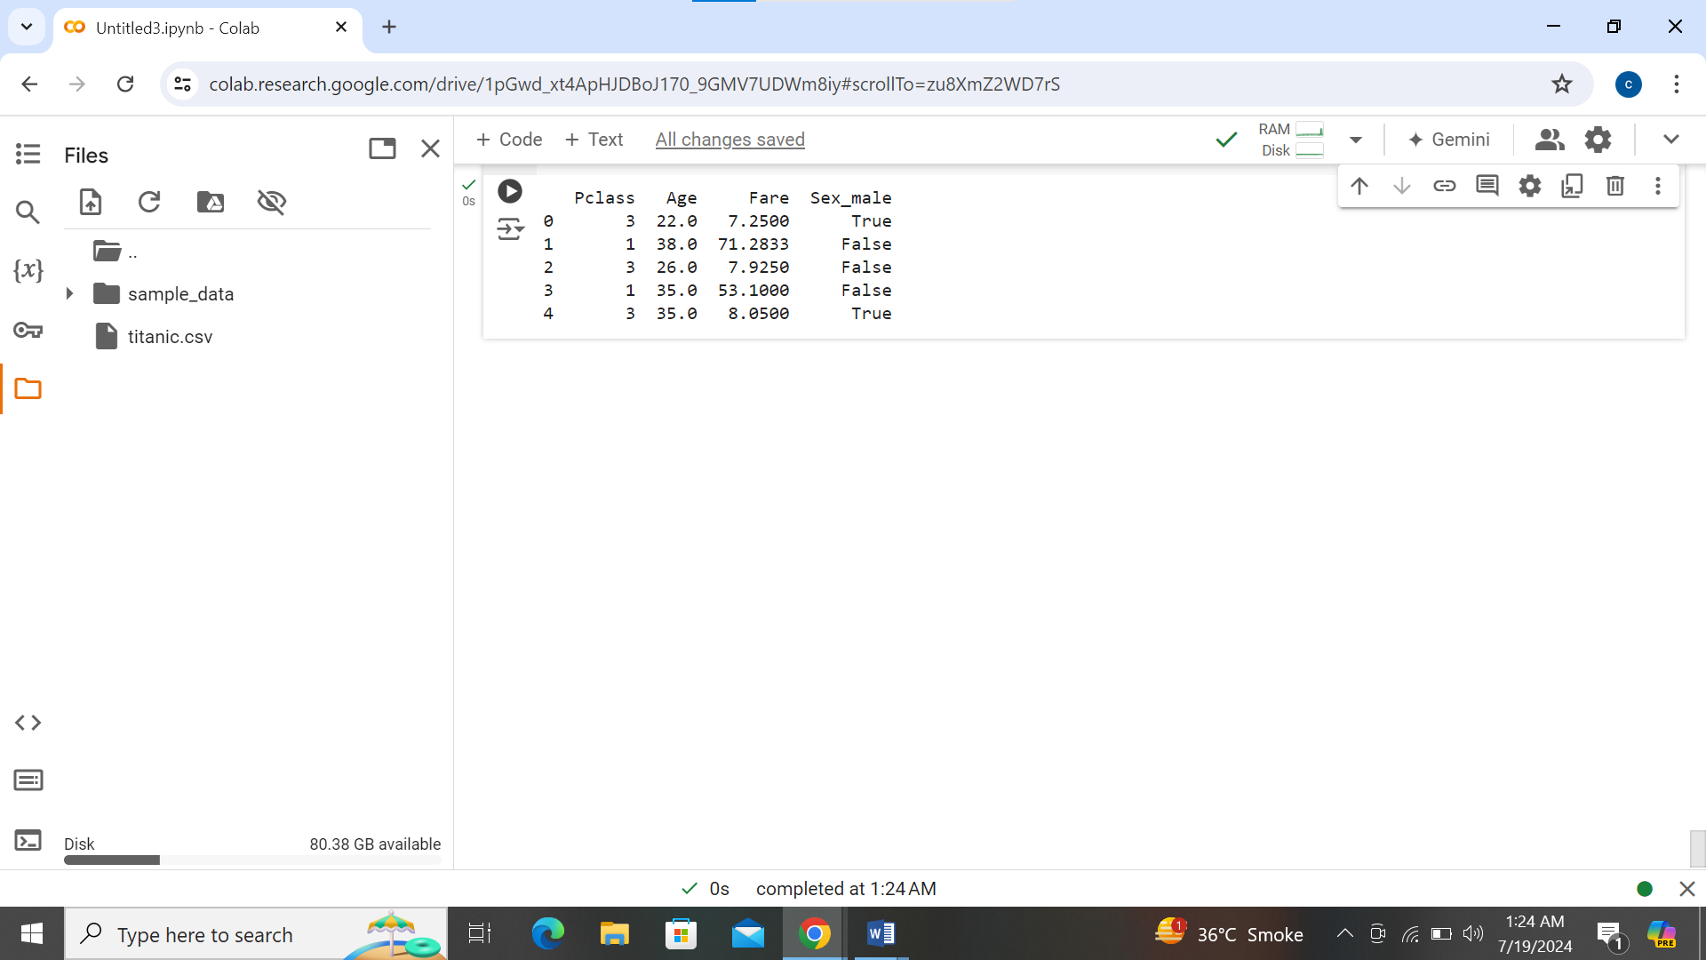

1. **Performance Estimation**: Cross-validation provides a more reliable estimate of model performance compared to a single train-test split. It reduces the variance in performance metrics by averaging results over multiple folds of the dataset.
2. **Generalization**: It helps assess how well the model generalizes to unseen data. By using different subsets of data for training and testing in each fold, cross-validation evaluates the model's ability to make accurate predictions on new, unseen data.
3. **Model Selection**: Cross-validation aids in comparing different models objectively. It allows you to evaluate multiple models using the same dataset splits, enabling a fair comparison of their performance metrics.
4. **Hyperparameter Tuning**: When tuning hyperparameters (e.g., regularization strength in logistic regression), cross-validation helps in selecting the optimal settings that generalize well to new data, reducing the risk of overfitting or underfitting.
5. **Data Quality Assessment**: It can reveal issues with data quality or model instability. Consistent performance across different folds suggests robustness, while significant variability may indicate data sensitivity or model instability.
6. **Bias-Variance Tradeoff**: By splitting data into training and validation sets multiple times, cross-validation helps in understanding the trade-off between bias (underfitting) and variance (overfitting). It guides adjustments to model complexity for optimal performance.

In summary, cross-validation is essential in model evaluation because it provides a more accurate estimate of how well your model will perform on unseen data. It enhances reliability in performance metrics, aids in model selection and hyperparameter tuning, and provides insights into generalization and data quality issues. It is a standard practice in machine learning for robust model evaluation and deployment.

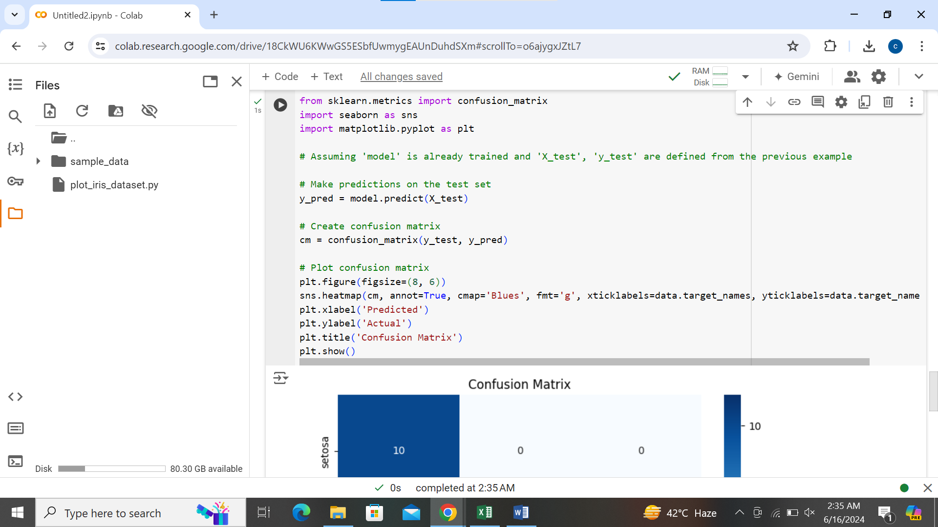

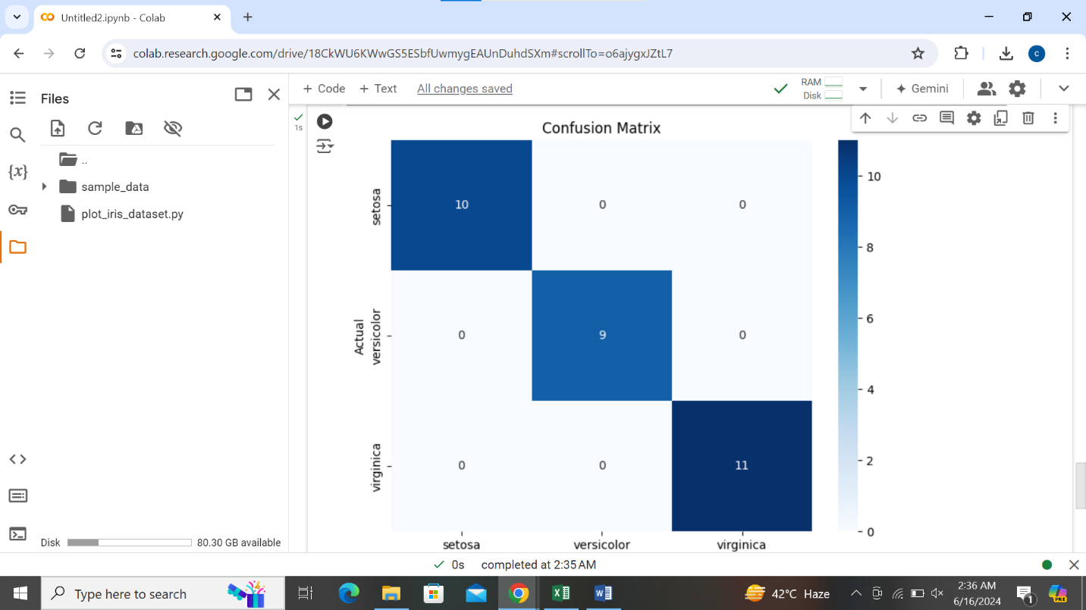

Top of Form

Bottom of Form

Top of Form

Bottom of Form

Top of Form

Bottom of Form